**Your Name: Munazza Ramzan**

**Course: HCCD-AI**

**KooLabs**

.

.

.

**Lab 1: Compute Services Practice**

Summary: In the **Huawei Cloud Compute Services Practice (Windows ECS)**, the process begins by setting up a **Virtual Private Cloud (VPC)** along with a **subnet and security group** to define the network structure. After that, a **Windows ECS (Elastic Cloud Server)** instance is launched, a **public IP** is allocated, and necessary **security rules** enabling RDP port 3389 are configured. Finally, the ECS is accessed remotely using **Remote Desktop Protocol (RDP)**. This exercise helps you understand how to deploy and manage a secure virtual machine in a cloud environment.

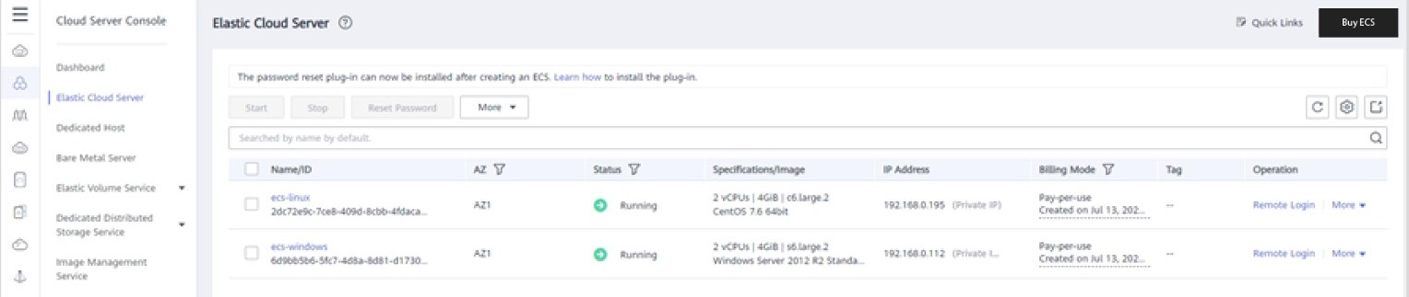

**Lab 2: Storage Services Practice**

Summary: In the **Huawei Cloud Storage Services Practice**, you begin by creating a **VPC**, followed by launching an **ECS instance** and setting up an **EVS (Elastic Volume Service) disk**. This disk is then attached to the ECS, where you remotely log in, initialize, and format it. Later, the disk is detached and reattached to a second ECS instance named **ECSTest**. After logging into ECSTest, you format the disk again and create a test file (test.txt) to confirm successful storage access. This exercise illustrates how to handle and transfer **block storage** between multiple cloud servers.

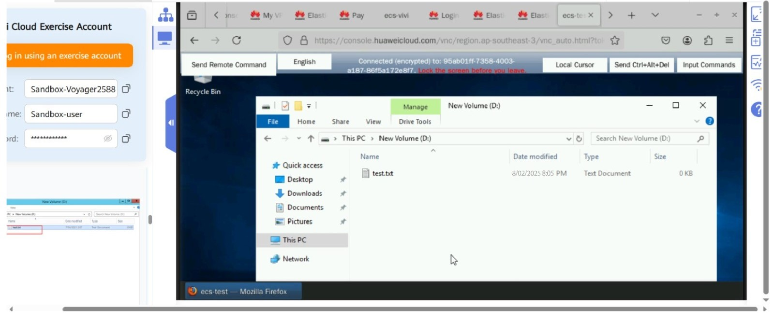

**Lab 3: Lab Name: Authentication of I am User**

Summary: In this task, you access your **Huawei Cloud account**, create multiple **users**, assign them the necessary roles or permissions, and download their **Access Key and Secret Key**. Using **Postman**, you then authenticate these users by making a **POST request** that includes a properly formatted **JSON body** along with essential **headers** such as Content-Type: application/json and Accept:application/json. Upon successful authentication, a **token** is generated, enabling secure access to Huawei Cloud APIs on behalf of the IAM user.

